Plate Tectonics – Supporting the theory of Continental drift
Continental Drift
In 1915, Alfred Wegner proposed his theory of Continental Drift. This theory states that the continents on earth are moving very slowly (drifting) across the surface of the Earth. Wegner proposed that about 180 million years ago the continents were once all joined together in a ‘supercontinent’ which he called Pangaea. Wegner proposed that this supercontinent eventually began to "break up" due to continental drift. His evidence for the new theory was significant and included:
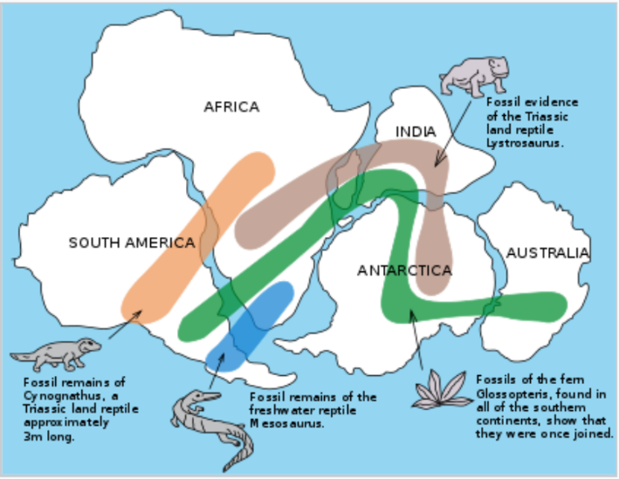
- The continents have matching shapes and can fit together (like a jigsaw puzzle).
- Worldwide distribution of fossils. Exactly the same fossils were found in places where the continents were once joined together, but which were now very far apart.
- Rock layers in mountain chains on one continent match up with the rock layers in mountain chains on another continent.
- Rocks and fossils in many places don’t match the present climate or conditions.
During Wegner’s lifetime his theory was not widely believed. Wegner was not able to explain what could cause such huge sections of the earth to move so slowly and for so long. In addition, most people simply believed that the world was stable – generally because they could not see any changes to the earth in their lifetime.
Plate Tectonics
During the 20th Century, further evidence arose which provided a lot of support for Wegner’s theory. This extra evidence came from advances in technology such as:
- The use of sonar in WWII led to the discovery of underwater trenches and volcanic seams under oceans
- The magnetic record of the ocean floor is a mirror image on either side of seams.
- Satellites have been used to measure the spreading of the ocean floor.
This new evidence made scientists take a closer look at trying to explain how the theory of Continental Drift could work… what forces could be moving the huge continents?
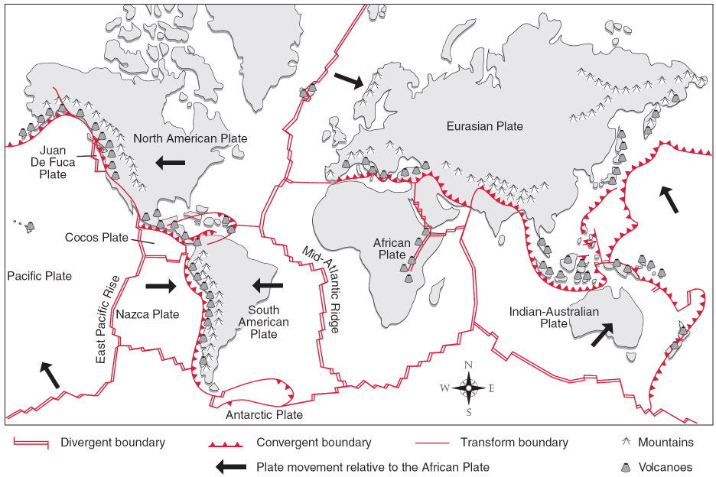
The new evidence led to scientists developing Plate Tectonics theory. Plate tectonics states that the crust of the Earth is split up into seven large plates (see map below) and a few smaller ones. (It was actually pretty easy to identify the separate plates as the boundaries where the plates meet is where all the earthquakes and volcanoes occur. If you map out all the earthquakes and the volcanoes on a map, this shows the plate boundaries.)
The plates all are able to slowly move (less than 10 cm per year) around on the Earth's surface. They “float”, or sit on the semi-molten mantle, and are moved around by convection currents within the mantle.

When scientists tried to explain the movement of the plates, they realised that continents sat on plates that were very different to the plates which were under the oceans. There appear to be two types of tectonic plates - continental plates and oceanic plates. Continental plates contain continents and are lighter (less dense) than oceanic plates. Oceanic plates are thinner than continental plates, but being much denser, they are lower, and are covered by oceans.
When plates collide (converging boundaries) the huge forces involved can build up slowly over time and can cause mountain ranges and volcanoes to form. When plates move apart (diverging boundaries), new molten rock can come to the surface and from brand new rock… the youngest rock on the earth. Earthquakes can occur at all plate boundaries as the movement of the plates gets “stuck”, and forces build up until it is suddenly released with rapid movement of the Earth (an earthquake).

Questions
- In what year did Alfred Wegner propose his theory of continental drift?
- What was the name of the super continent Wegner proposed?
- List (briefly… summarise) the four main pieces of evidence Wegner used to support his theory?
- Imagine over 100 years ago, without the advent of technology, hearing about Wegner’s theory that the surface of the earth was constantly moving very slowly? Would you have believed it? Explain why or why not?
- What new evidence was found during the 20th century to support the theory of continental drift?
- How many plates are named on the map?
- In your own words clearly explain the difference between the theory of continental drift, and the theory of plate tectonics

